# **25 Things I Believe About Myself**

### Happy birthday to me!

Zoe's avatar

[Zoe](https://substack.com/@zoeffc)

Apr 04, 2025

1

[1](https://femmefuturescooperative.substack.com/p/25-things-i-believe-about-myself/comments)

Share

Hi y’all,

Today is my 25th birthday. I don’t know if that feels old or young, but I do know that it feels like something work celebrating. You guys already got my gift to you — we got an awesome bonus note on Wednesday that if you haven’t caught up on yet, you really ought to ([link here](https://femmefuturescooperative.substack.com/p/from-a-friend-vol-1)). Today is my gift to myself — some free range naval gazing for my birthday.

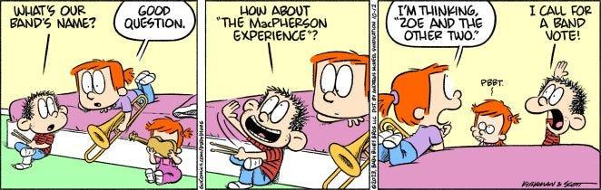

Before I go any further — let’s do the housekeeping.

First, if you are not already a subscriber and you resonate with any of the following descriptors, consider joining the cooperative: (1)Early-career professional; (2) Feminist; (3) Do-Gooder; (4) Former Gifted Kid; (5) Overachiever; or (6) Capitalism-hater.

Subscribed

Second, if you like what I am saying and it makes you think of someone in your family/office/friend group, send it their way.

[Share Femme Futures Cooperative](https://femmefuturescooperative.substack.com/?utm_source=substack&utm_medium=email&utm_content=share&action=share)

Third, I say some personal and vulnerable shit every week. Say some vulnerable shit back. It’s called a community.

[Leave a comment](https://femmefuturescooperative.substack.com/p/25-things-i-believe-about-myself/comments)

Okay — back to it.

Birthdays are for reflections — at least that’s always how I have felt about them. For this birthday, as my brain is finally coming into it’s final form, I wanted to reflect on who I am as a person. Originally, I was going to write “25 things that I know about myself”, but if I know myself at all, I know that those 25 things might change and really how written in stone are they. Instead, I have written 25 things I believe about myself. I wanted to allow for fluidity in who I am an how I might grow. I hope that you enjoy it and learn a little bit more about me.

**25 Things I Believe About Myself (in no particular order):**

1. I am an early bird.
2. I was not built for staying awake past 11 and I am ok with that.
3. I am a good friend.
4. I am picky when it comes to the people I let myself love.
5. I will always feel a little better after sitting in the sun.
6. I am stronger than I think I am – physically and mentally.
7. I am more resilient than I think I am.
8. I like my coffee sweet and a little spicy. (If you haven’t tried putting a bit of cayenne and a bit of cinnamon in your coffee, I’m telling you… you gotta)
9. I will not finish a book if I don’t like it (and am not reading it for book club).
10. I like reading books that are plot driven.
11. I don’t like books that are overly descriptive unless they are super poetic and then I will come back around to it.
12. I don’t mind walking away from a movie in the middle. (And I am really really bad at finishing TV shows)
13. I am constantly working to be better.
14. I suck at following recipes but I am a pretty decent cook.
15. I like expressing myself through creative writing.
16. I like learning new things but I hate being bad at things.
17. I get road rage but that just means that I gentle parent the other drivers on the road.
18. I really like my job as a project manager probably because I like order, control, and delegation.
19. I don’t like pranks, but I love a good laugh.
20. I take myself too seriously.
21. I love country music and probably always will.
22. I will say that I don’t like musicals, but there is always an exception that I will point out.
23. I like weekend mornings spent walking on trails with friends.
24. I like driving – to the mountains or to the grocery store, I just like being behind the wheel.
25. I am pretty cool/interesting/genuine.

I hope you all have a lovely weekend.

Best,

Zoe